**CODE EXPLAINATION FOR CREATING HEATMAPS THROUGH SEABORN LIBRARY**

* **Firstly I imported the data from github url and then I applied pandas read function to create a DataFrame**

#USING PANDAS READ METHOD IMPORTING URL

url='https://raw.githubusercontent.com/resbaz/r-novice-gapminder-files/master/data/gapminder-FiveYearData.csv'

Data=pd.read_csv(url,sep=',')

Data.head()

* **In this code I check for missing or null values through .info function**

Data.info()

#As we see Dataframe has zero null or missing values

* **IN THIS CODE I CHECK TOTAL NO OF RECORDS i.e. rows and FEATURES i.e. columns**

**THROUGH SHAPE ARGUMENT**

Data.shape

#This shows DataFrame has 1704 rows and 6 columns

* **THEN I CREATE A PIVOT TABLE DATFRAME USING PIVOT_TABLE FUNCTION TO CREATE A WIDE TABLE**

Pivot_DF=Data.pivot_table(index='country',columns='year',values='lifeExp')

Pivot_DF.head()

* **I CREATED HEATMAP ON TOP OF PIVOT TABLE USING SEABORN PACKAGE AND IN HEATMAP FUNCTION I PASSED PARAMETERS AS DATAFRAME,ANNOT AND FMT**
* **THEN I SAVED THIS HEATMAP IN .PNG FILE USING SAVEFIG FUNCTION**
* **ANNOT=TRUE – THIS IS TO SHOW NUMERIC VALUES ON THE TOP OF HEATMAP IN EVERY RECTANGLE GRID**
* **FMT-IS TO SHOW FORMAT IN CASE OF ANNOT=TRUE IF VARIABLE IS FLOAT TYPE THEN WE PASS ‘f’ AND IF NOT FLOAT THEN WE PASS ‘d’**
* **Plt.figure()-IN THIS I PASS figsize Parameter which is used to change the width and height of plot**
* **Get_figure- THIS FUNCTION USED TO CREATE A FIGURE AND ON TOP OF THIS FUNCTION SAVEFIG FUNCTION IS APPLIED**

plt.figure(figsize=(32,30))

sns.heatmap(data=Pivot_DF,annot=True,fmt='f').get_figure().savefig('HEAT_MAP1.png')

* **THEN I CREATED ANOTHER FILTERED HEATMAP OF TOP 11 RECORDS USING CENTER PARAMETER**
* **CENTER- THROUGH THIS PARAMETER I CHANGE THE CENTER OF COLORMAPPING IN HEAT MAP.THIS MEANS BELOW AND ABOVE THE VALUE GIVEN IN CENTER PARAMETER THE COLOUR SYMMMETRY IS ESTABLISHED**

plt.figure(figsize=(20,18))

Pivot_DF1=Pivot_DF.head(11)

sns.heatmap(data=Pivot_DF1,annot=True,fmt='f',center=Pivot_DF1.loc['Australia’,1982]).get_figure().savefig('HEAT_MAP2.png')

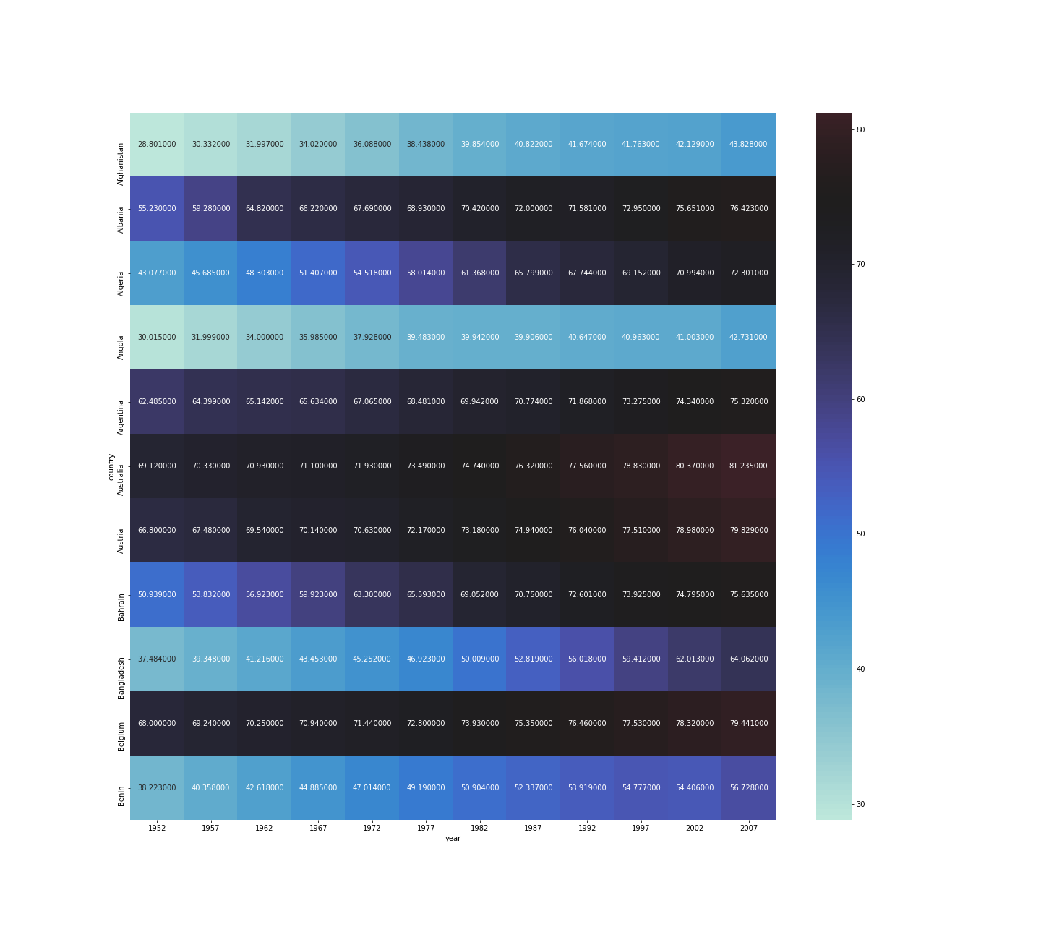

***HEAT MAP USING CENTER ATTRIBUTE WITH TOP 11 COUNTRIES***